# USER GUIDE

To begin using **Healthcare**, follow these steps:

1. open the following link in your browser of choice. you must replace localhost by the domain or IP where the application is hosted.

<http://localhost/health-app/login>

1. On the login page you can use the following administrator user with which you can create more users.

|  |  |
| --- | --- |
| User name | Admin |
| Password | 123456 |

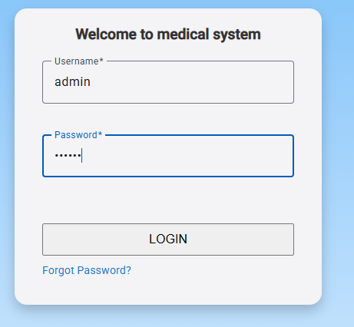

1. click on the Login button.

**explanatory note**: for the current application the “Forgot password?” functionality was not included.

1. the application places you on the base page of the system where you will find on the right a button that displays the options. This is shown in the following image:

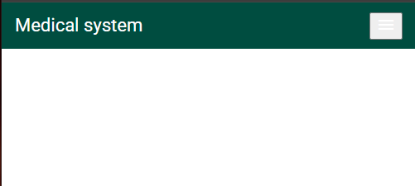

1. click on the button located on the right side at the top of the screen.

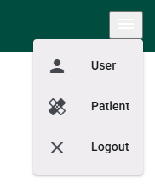

1. you will see three options such as User, Patient, Logout.

**User Menu Option**

1. click on the user menu option.

A page is displayed where you will have the option to add a new user, as well as a box that will allow you to filter the information in the table below. The table will show the options to edit and delete.

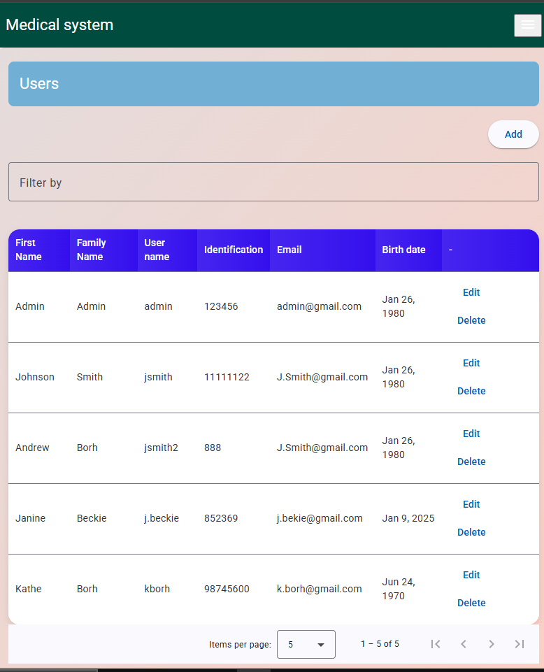

**Create new user**

1. click on the upper right button “Add”.

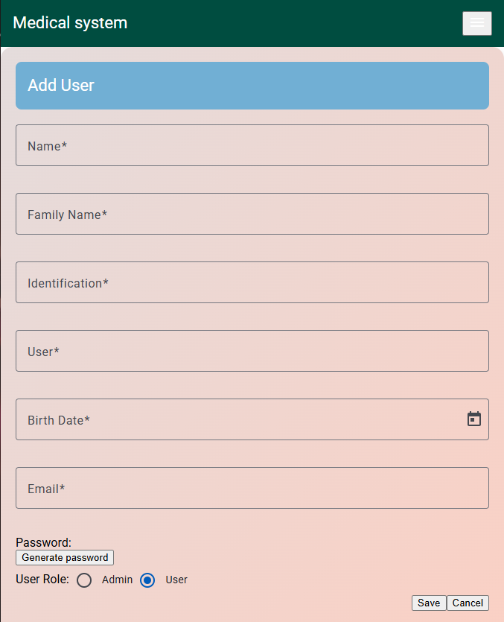

1. Enter the requested user information.
2. Click on the “Generate password” button to assign the password to access the application and finally assign a role.

The application manages two roles, 1) ADMIN, which assigns access to all the system's functionalities. 2) USER, who only has access to the patient menu.

1. click the Save button to add the user.

**Edit user option in the information table**

On the main user page, at the bottom where the existing users are displayed, on the right side you will find the edit option.

1. Click on the edit option. The page with the user information to be modified will open.

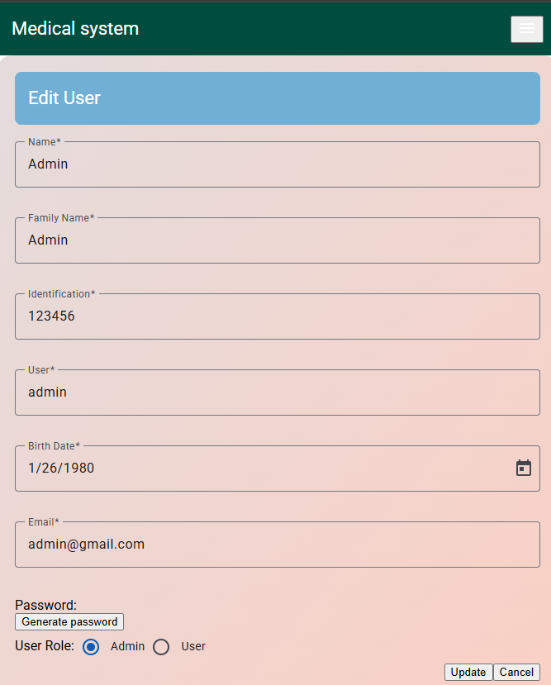

1. Make changes to the user information and click Save.

If you do not click on generate password, the application will keep the current password.

**Patient Menu Option**

1. click on the patient menu option.

A page is displayed where you will have the option to add a new patient, as well as a box that will allow you to filter the information in the table below. The table will show the options to edit and delete.

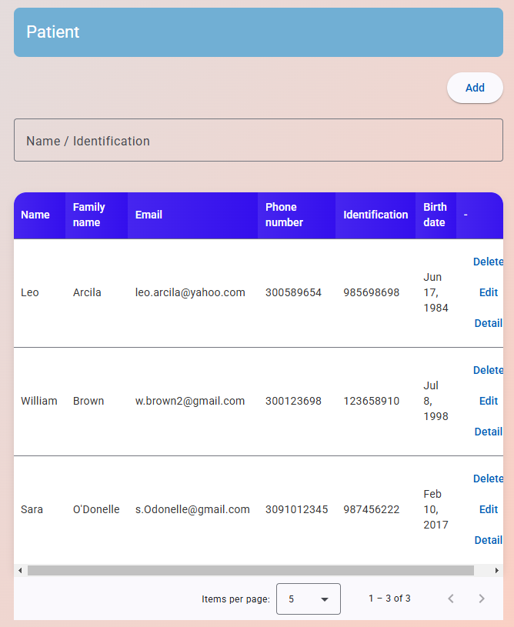

**Create new patient**

1. click on the upper right button “Add”.

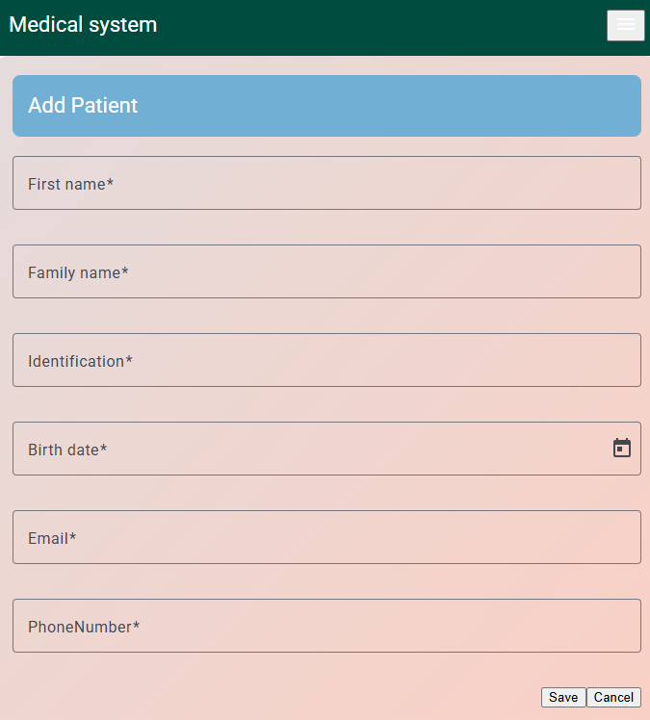

1. Enter the requested patient information.
2. click on the save button.

**Edit patient option in the information table**

On the main patient page, at the bottom where the existing patients are displayed, on the right side you will find the edit option.

1. Click on the edit option. The page with the patient information to be modified will open.

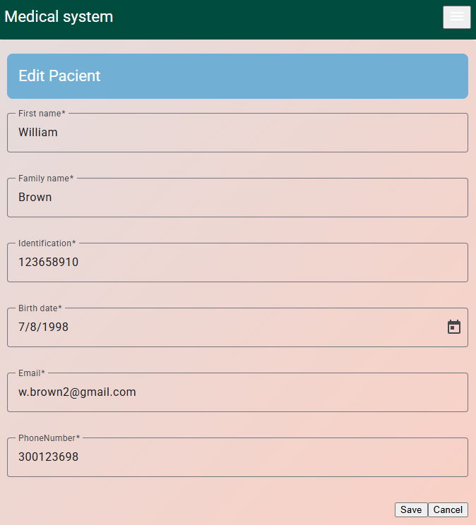

1. Once the changes have been made click on save.

**Patient follow-up information**

On the main page where the patients are displayed. In the table on the right side you will find the detail option. Click on detail.

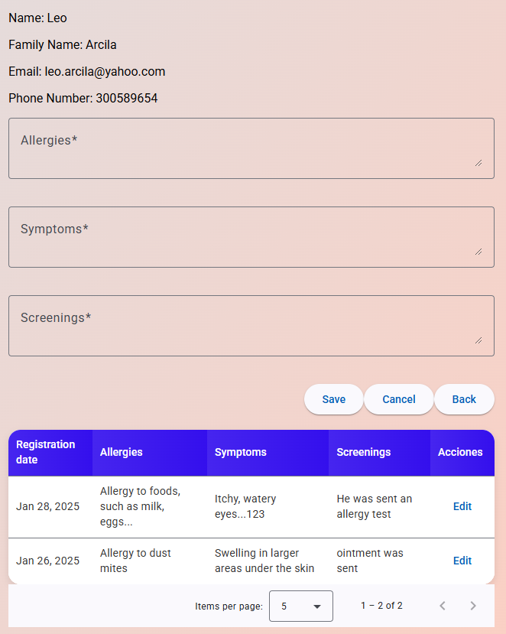

It redirects to the page where the patient's follow-up is found. Only the option to add new follow-up or to modify it is presented, but not to delete it.

To add new follow-up, just enter the information in the allergy, symptoms and screening fields.

To modify the tracking information click on edit.